INDUSTRIAL TRAINING REPORT

AI Research Paper Simplifier

Submitted in partial fulfilment of the
Requirements for the award of

Degree of Bachelor of Technology in
Computer Science and Engineering



SUBMITTED BY:

Name: Varinder Singh
University Roll No: 2206401

SUBMITTED TO: Er. Palak Puri
Department Engineering and Nano Technology

Rayat Bahra Institute of Engineering and Nano Technology, HOSHIARPUR

Certificate

DECLARATION

I hereby declare that the Industrial Training Report entitled “AI Research Paper Simplifier” is an authentic record of my own work as requirements of 6-months Industrial Training during the period from January 2026 to June 2026 for the award of degree of B.Tech. CSE, Rayat Bahra Institute of Engineering and Nano Technology Hoshiarpur, under the guidance of Er. Palak Puri

Date: ____________________

Varinder Singh (2206401)

Certified that the above statement made by the student is correct to the best of our knowledge and belief.

Signatures

Examined by:
1. 2. 3. 4.

Head of Department
(Signature and Seal)
Acknowledgment

Through this acknowledgement, I express our sincere gratitude to all those people who have been associated with this project and have helped me with it and made it a worthwhile experience.

I would like to thank Er. Gagan Sharma for his immense support as my project guide, as well as the faculty member of O7 Services, for their valuable assistance in completing the project. The atmosphere provided by them fostered knowledge acquisition and enthusiasm. Their assistance in resolving doubts contributed to the project's success within a limited time.

I would also like to thank everyone who has knowingly and unknowingly helped me throughout my work. Last but not least, a word of thanks for the authors of all those books and papers which I have consulted during my project work as well as for preparing the report.

Varinder Singh (2206401)
B. Tech (CSE) 8th Sem

COMPANY PROFILE


COMPANY NAME: O7 Services
LOCATION: Hoshiarpur
MY PROFILE: Trainee Technology

About Organization:

O7 Services is an ISO 9001:2015 Certified company founded in 2015. They
specialize in a variety of services including Web Development, Mobile Application
Development, AI Bot, Machine learning Algorithm, Data Analytics, Cloud Computing,
Cyber Security, Custom Software Development, UI/UX design, Hosting services,
Digital Marketing, Registration of Domain Names with various extensions, AMC &amp;
MMC Services, Bulk SMS and voice calls. O7 Services offers advanced IT solutions
supporting the entire business cycle - from consulting to system development,
deployment, quality assurance, and 24x7 support. With over 10 years of experience,
the company aims to form long-lasting strategic partnerships with clients, offering
affordable prices, timely delivery, and measurable business results. Their
headquarters are located in Jalandhar with a branch office in Hoshiarpur.
Some of the products developed by O7 Services include Vehicle Tracking System,
Invoice Software, School Management System, Hospital Management System,
Parents-Teacher Communication App, Fee Management system, Task Management
System, Online Food Ordering App, Security App, Admission system, Inventory
Software, and Car Servicing App. Additionally, O7 Services provides training
programs including 6 Weeks/6 Months Industrial Training, Project-Based Training,
Corporate Training, and Job-Oriented Courses Training, covering major IT trends
such as Full Stack Development (MEAN/MERN), Flutter, Kotlin Android, Swift UI
(iOS), Firebase, Python, Angular, React Js, Vue Js, Node Js, ASP.NET, .NET Core,
PHP, Laravel, CodeIgniter, Software Testing, Cloud Computing, Blockchain,
DevOps, Data Science, Artificial Intelligence, Machine Learning, UI/UX Designing,
Digital Marketing, WordPress, Linux, CCNP, CCNA Security, Network Security,
Cyber Security, MCSE, MCITP, Java, Spring, Hibernate, C/C++, Photoshop, Adobe
Illustrator, Figma, CorelDraw and many more.
+91- 8437365007, +91-181-5015007
E-Mail: enquiry@o7services.com , hr@o7services.com











TABLE OF CONTENTS

Name of Topic | Page No.
CHAPTER 1: INTRODUCTION
1.1 Introduction about project | 1
1.2 Oobjective | 2
1.3 Existing System | 3
1.4 Proposed System | 4
1.5 Project Scope | 5
1.6 Advantages | 6
1.7 Disadvantages | 7
CHAPTER 2: TOOLS & TECHNOLOGY
2.1 Software requirements | 8
2.2 Hardware requirements | 8
2.3 Introduction to python  2.4 Introduction of Django framework  2.5 Introduction to Data Science  2.6 Introduction to Deep Learning  2.7 Introduction to Machine Learning  2.8 Introduction to Stream lit | 9-11  12-15  16-18  19-21  22-23  24-26
CHAPTER 3: FEASIBILITY STUDY
3.1 Technical Feasibility | 27-28
3.2 Economic Feasibility | 29-30
3.3 Operational Feasibility | 31-32
CHAPTER 4: PROJECT WORK
4.1 Work | 32-34
4.2 Backend Technologies  4.3 Frontend Technologies Working | 35-36  37-38
CHAPTER 5: DFD DIAGRAM OF VEHICLE DEALING SYSTEM

5.1 DFD Diagram | 39
5.2 Components involved in DFD | 40
CHAPTER 6: WORKING
6.1 Project Working Flowchart | 41
6.2 Project Working | 42-44
CHAPTER 7: WORKING SCREENSHOTS | 45-47
CHAPTER 8: CONCLUSION
8.1 Conclusion | 48-49
8.2 Applications | 50-51
8.3 Future Scope  CHAPTER 9:  9.1 Reference | 52-53  54

CHAPTER 1: INTRODUCTION
Introduction about Project
The rapid growth of research in fields like Artificial Intelligence, Machine Learning, and Data Science has resulted in an overwhelming number of research papers being published every day. While these papers contribute significantly to technological and scientific advancement, they are often complex, lengthy, and difficult to understand for students, beginners, and even professionals from other domains. This creates a barrier to knowledge accessibility and slows down the learning process.
An AI Research Paper Simplifier is an intelligent system designed to automatically analyse, summarize, and simplify complex academic papers into concise and easy-to-understand language. The primary goal of such a system is to bridge the gap between advanced research and general comprehension by transforming dense academic content into simplified explanations without losing the core meaning.
At the heart of this system lies advanced techniques from Natural Language Processing (NLP), a branch of AI that enables machines to understand, interpret, and generate human language. Using NLP, the simplifier can extract key ideas, identify important sections, and rephrase technical content into simpler terms. Modern models such as Transformer architecture-based systems have significantly improved the performance of such tools by enabling contextual understanding of text.
The system typically performs two major tasks: summarization and simplification. Summarization involves condensing the research paper into a shorter version that highlights the main points, while simplification focuses on rewriting the content in a more understandable and less technical manner. These tasks can be achieved using techniques like extractive summarization (selecting key sentences) and abstractive summarization (generating new simplified sentences).
Recent advancements in pretrained language models such as BART and T5 have made it possible to build highly efficient and accurate research paper simplifiers. These models are trained on large datasets and can generalize well across different domains, making them suitable for handling diverse academic content.
An AI Research Paper Simplifier typically works through a pipeline that includes data preprocessing, text segmentation, key information extraction, summarization, simplification, and output generation. Some systems also include features like keyword highlighting, section-wise summaries, and question-answer generation to enhance user understanding.
The importance of such a system is evident in educational and professional settings. Students can use it to quickly grasp complex topics, researchers can review literature more efficiently, and professionals can stay updated with the latest advancements without investing excessive time. Additionally, it promotes inclusivity by making research accessible to non-experts and individuals with limited technical backgrounds.
In conclusion, an AI Research Paper Simplifier is a powerful application of artificial intelligence that enhances knowledge accessibility and productivity. By combining the capabilities of NLP and deep learning, it transforms the way people interact with academic content, making research more approachable, understandable, and useful for a wider audience.

objectives:
Objectives of AI Research Paper Simplifier
The main objective of an AI Research Paper Simplifier is to make complex academic research more accessible, understandable, and time-efficient for users. The system leverages advanced techniques from Artificial Intelligence and Natural Language Processing to process and transform dense research content into simplified formats.
To Simplify Complex Research Content
One of the primary objectives is to convert highly technical and complex research papers into simpler language. Research papers often contain domain-specific jargon, mathematical notations, and complex sentence structures. The system aims to rewrite this content into easy-to-understand language without losing its original meaning.
To Generate Concise Summaries
The system should be capable of producing short and meaningful summaries of long research papers. Using techniques such as extractive and abstractive summarization, it highlights key ideas, methodologies, and conclusions, reducing reading time significantly.
To Enhance Knowledge Accessibility
Another important objective is to make research papers accessible to a broader audience, including students, beginners, and professionals from non-technical backgrounds. By simplifying content, the system bridges the gap between experts and general readers.
To Improve Learning Efficiency
The tool helps users quickly grasp important concepts and insights from research papers. This is particularly beneficial for students and researchers who need to review multiple papers in a limited time.
To Automate Literature Review Process
The system aims to assist in literature review by quickly summarizing multiple research papers. This reduces manual effort and allows researchers to focus on analysis and innovation rather than reading lengthy documents.

To Utilize Advanced NLP Models
A key objective is to implement state-of-the-art models such as BART and T5 for high-quality summarization and simplification. These models enable contextual understanding and accurate text generation.
To Maintain Context and Accuracy
While simplifying and summarizing, the system must preserve the original meaning, context, and important details of the research paper. Ensuring factual correctness is critical.
To Provide Section-wise Insights
The system can break down research papers into sections such as abstract, methodology, and conclusion, and generate summaries for each section. This structured approach improves readability and understanding.
To Support Multiple Domains
The simplifier should be capable of handling research papers from various domains such as computer science, medicine, engineering, and social sciences, making it versatile and widely applicable.
To Develop a User-Friendly Interface
Another objective is to design an intuitive interface where users can upload research papers and easily view simplified outputs, summaries, or key highlights.

Existing System:
Here is your modified content with “AI Research Paper Simplifier” replacing “new vehicle service system,” written clearly for your project:
Drawbacks of Existing Systems Addressed by AI Research Paper Simplifier
Here are some common drawbacks of existing systems that can be addressed with an AI Research Paper Simplifier, which utilizes techniques from Artificial Intelligence and Natural Language Processing:
1. Complexity of Research Papers
Existing academic papers are often written in highly technical language that is difficult for beginners and non-experts to understand. An AI Research Paper Simplifier addresses this issue by converting complex text into simpler, more readable language.
2. Time-Consuming Reading Process
Reading and understanding lengthy research papers requires significant time and effort. The simplifier reduces this burden by generating concise summaries and highlighting key points, enabling faster comprehension.
3. Information Overload
With the rapid growth of research publications, users often face difficulty selecting and understanding relevant information. The system filters essential content and presents it in a structured and digestible format.
4. Lack of Accessibility
Many existing systems do not cater to users with limited technical backgrounds. By simplifying content, the AI Research Paper Simplifier makes research accessible to students, beginners, and interdisciplinary professionals.
5. Inefficient Literature Review
Traditional literature review involves manually reading multiple papers, which is inefficient and time-consuming. The system automates this process by summarizing multiple documents quickly and effectively.

6. Poor Context Understanding in Basic Tools
Basic summarization tools often fail to maintain context and may produce inaccurate or incomplete summaries. Advanced models like BART and T5 used in AI-based systems improve contextual understanding and output quality.
7. Lack of Structured Output
Existing tools may not organize content effectively. An AI Research Paper Simplifier can provide section-wise summaries (abstract, methodology, conclusion), improving readability and usability.
8. Limited Domain Adaptability
Many traditional systems are not flexible across different research domains. AI-based systems can generalize across various fields, making them more versatile.

Proposed System:
The proposed system is an intelligent application designed to automatically simplify complex research papers into easy-to-understand summaries. It leverages advanced techniques from Natural Language Processing and Machine Learning to transform technical content into simplified language while preserving the original meaning.
The system aims to assist students, researchers, and professionals by reducing the time and effort required to understand dense academic documents.
2. System Architecture
The system follows a modular architecture consisting of the following components:
a. Input Module
- Accepts research papers in formats such as PDF, DOCX, or plain text.
- Extracts raw text using document parsing tools.
b. Preprocessing Module
- Cleans and processes the extracted text.
- Performs:
  - Tokenization
  - Stop word removal
  - Sentence segmentation
- Prepares structured input for the model.
c. Summarization Engine
- Uses pre-trained transformer models such as:
  - BART model
  - T5 model
- Performs:
  - Extractive summarization (important sentences)
  - Abstractive summarization (rephrased output)
d. Simplification Module
- Converts complex sentences into simpler ones.
- Uses:
  - Lexical simplification (difficult → easy words)
  - Syntactic simplification (shorter sentences)

e. Output Module
- Generates:
  - Short summary
  - Simplified explanation
  - Key points
- Displays results in a user-friendly interface.
3. Working Process
- User uploads a research paper.
- System extracts and preprocesses text.
- Summarization model generates a concise version.
- Simplification module rewrites the summary in simple language.
- Final output is displayed to the user.

4. Technologies Used
- Programming Language: Python
- Libraries: Transformers, NLTK, SpaCy
- Frameworks: Flask / Django (for web interface)
- Models:
  - BART
  - T5

5. Key Features
- Automatic research paper summarization
- Easy-to-understand simplified content
- Multi-format document support
- Time-efficient processing
- User-friendly interface
6. Advantages of Proposed System
- Reduces complexity of academic papers
- Saves time for students and researchers
- Improves accessibility of technical knowledge
- Helps beginners understand advanced topics

Project Scope
1. Overview
The scope of this project focuses on developing an intelligent system that simplifies complex academic research papers into concise and easy-to-understand content. Using techniques from Natural Language Processing and Machine Learning, the system aims to bridge the gap between technical research and general understanding.

2. Functional Scope
The proposed system will include the following functionalities:
- Document Input Handling
Supports uploading research papers in formats such as PDF, DOCX, and TXT.
- Text Extraction & Preprocessing
Extracts and cleans text for further processing.
- Automatic Summarization
Uses models like BART and T5 to generate concise summaries.
- Text Simplification
Converts complex technical language into simpler, more readable content.
- Output Generation
Provides:
  - Simplified summaries
  - Key points
  - Easy explanations

3. Application Scope
The system can be used in multiple domains:
- Education Sector
Helps students understand research papers easily.
- Research Community
Assists researchers in quickly reviewing literature.
- Self-Learning Platforms
Useful for beginners exploring advanced topics.
- Professional Use
Helps professionals stay updated with minimal effort.

4. Technical Scope
- Implementation using Python and NLP libraries
- Integration of transformer-based models
- Web-based or desktop interface development
- Scalable architecture for future enhancements

5. Limitations of Scope
- May not fully preserve deep technical nuances
- Accuracy depends on the quality of pre-trained models
- Complex mathematical or domain-specific content may not simplify perfectly

6. Future Scope
- Multilingual research paper simplification
- Domain-specific models (medical, legal, etc.)
- Voice-based summaries
- Integration with research platforms like Google Scholar

Advantages:
1. Saves Time and Effort
The system quickly converts lengthy and complex research papers into concise summaries, reducing the time required for reading and understanding.

2. Improves Understanding
By using techniques from Natural Language Processing, the system simplifies difficult terminology and complex sentence structures, making content easier to grasp for beginners and non-experts.

3. Enhances Productivity
Students and researchers can review multiple papers in less time, allowing them to focus more on analysis and innovation rather than just reading.

4. Accessibility for All Users
The system makes research content accessible to:
- Students
- Non-technical users
- Professionals from different domains
Even users without deep technical knowledge can understand advanced topics.

5. Automatic Summarization
With the help of models like BART and T5, the system automatically generates meaningful summaries without manual effort.

6. Reduces Information Overload
Research papers are often lengthy and dense. The system extracts only the most important information, helping users focus on key insights.

7. User-Friendly Interface
The proposed system is designed to be simple and intuitive, allowing users to upload documents and get results without technical expertise.

8. Supports Multiple Formats
It can process different file formats such as PDF, DOCX, and TXT, making it flexible and convenient.

9. Encourages Learning and Research
By simplifying content, the system motivates students to explore more research papers without fear of complexity.

10. Scalable and Extensible
The system can be enhanced in the future with:
- Multilingual support
- Voice-based explanations
- Domain-specific models

Disadvantages:
1. Loss of Technical Depth
While simplifying content, the system may remove or reduce important technical details, which can be critical for advanced researchers.

2. Accuracy Limitations
The quality of output depends on models like BART and T5. These models may sometimes:
- Misinterpret context
- Generate incomplete or slightly incorrect summaries

3. Difficulty with Complex Content
Highly technical areas such as mathematics, formulas, or domain-specific jargon (e.g., medical or legal research) may not be simplified effectively.

4. Dependence on Training Data
The system relies heavily on pre-trained data from Machine Learning models. If the training data lacks diversity, the output quality may be biased or limited.

5. Computational Cost
Running transformer-based models requires:
- High processing power
- Good GPU/CPU resources
This may increase system cost and limit accessibility for low-end devices.

6. Limited Context Understanding
Although based on Natural Language Processing, the system may struggle with:
- Deep contextual meaning
- Ambiguity in research writing
7. Over-Simplification Risk
Excessive simplification may lead to:
- Loss of original intent
- Misrepresentation of research findings

8. Dependency on Internet (if deployed online)
If the system is web-based, it may require a stable internet connection for processing and accessing models.

9. Not a Replacement for Full Reading
The system provides summaries, but it cannot fully replace reading the complete research paper for:
- Detailed understanding
- Critical analysis

10. Maintenance and Updates Required
The system needs regular updates to:
- Improve model performance
- Keep up with new research trends

CHAPTER 2: TOOLS & TECHNOLOGY
2.1 SOFTWARE REQUIREMENTS: -
1. Overview
The development and execution of the AI Research Paper Simplifier require a combination of programming tools, frameworks, and libraries. These software components enable efficient implementation of techniques from Natural Language Processing and Machine Learning.
2. Operating System
- Windows 10 / 11
- Linux (Ubuntu recommended)
- macOS (optional)
3. Programming Language
- Python 3.x
  - Preferred due to strong support for AI and NLP libraries
4. Development Environment (IDE/Editors)
- Visual Studio Code
- PyCharm
- Jupyter Notebook
5. Libraries and Frameworks
- NLP Libraries:
  - NLTK
  - spaCy
- Deep Learning / Transformer Libraries:
  - Transformers
  - PyTorch or TensorFlow
- Summarization Models:
  - BART
  - T5
6. Web Framework (Optional for Deployment)
- Flask
7. Database (Optional)
- MySQL
8. Document Processing Tools
- PyPDF2 (for PDF text extraction)
- python-docx (for DOCX files)
9. Version Control
- GitHub
10. Browser (for Web Interface)
- Google Chrome
- Mozilla Firefox
11. Additional Tools
- Anaconda (for environment management)
- Postman (for API testing
12. Minimum Software Configuration
- Python 3.8 or above
- 8 GB RAM recommended
- Internet connection for downloading models.

2.2 HARDWARE REQUIREMENTS: -
1. Processor (CPU)
- Minimum: Intel Core i5 / AMD Ryzen 5
- Recommended: Intel Core i7 / Ryzen 7 or higher
- Why needed:
  - Handles data preprocessing, text cleaning, and system operations
  - Multi-core CPUs improve performance for parallel tasks
2. Graphics Processing Unit (GPU)
- Minimum: Not mandatory (CPU can run small models)
- Recommended: NVIDIA GPU (RTX 3060 / 4060 or higher)
- Advanced (training): RTX 3090 / A100 (for large models)
Importance:
- Speeds up training and inference of transformer models
- Handles matrix operations in deep learning efficiently
VRAM Requirement:
- Small models (BERT, DistilBERT): 4–8 GB
- Medium models (BART, T5): 8–16 GB
- Large models: 16–24+ GB
3. RAM (Main Memory)
- Minimum: 8 GB
- Recommended: 16–32 GB
- High-end: 64 GB (for large datasets)
4. Storage
- Minimum: 256 GB SSD
- Recommended: 512 GB – 1 TB SSD
5. Additional Hardware (Optional but Useful)
a) TPU / Cloud GPU
- Google Colab / Kaggle / AWS GPU
- Useful if local system is weak
b) High-speed Internet
- Required for:
  - Downloading datasets
  - Accessing pre-trained models
6. Hardware Requirements Based on Use Case
🔹 Basic Project (College Level)
- CPU: i5
- RAM: 8–16 GB
- GPU: Not required
- Storage: 256–512 GB SSD
🔹 Intermediate (Using Pre-trained Models)
- CPU: i7
- RAM: 16–32 GB
- GPU: 8–12 GB VRAM
- Storage: 512 GB SSD
🔹 Advanced (Training Your Own Model)
- CPU: i9 / Ryzen 9
- RAM: 32–64 GB
- GPU: 16–24 GB VRAM
- Storage: 1 TB SSD
2.3 INTRODUCTION TO PYTHON
Python is a popular programming language known for its simplicity, readability, and versatility. It was created by Guido van Rossum and first released in 1991. Python emphasizes code readability with its clean syntax and uses indentation to define code blocks, making it an excellent choice for beginners and experienced programmers alike. Python is a high-level language, meaning that it abstracts away many low-level details, making it easier to write and understand code. It supports multiple programming paradigms, including procedural, object-oriented, and functional programming. Here are some key features of Python:
Readability: Python uses a clear and expressive syntax, making it easy to read and understand code. It enforces the use of whitespace indentation, which enhances code readability.
Extensive Standard Library: Python comes with a vast standard library that provides a wide range of modules and functions for various tasks. It simplifies many common programming tasks, such as file handling, networking, and data processing.
Cross-Platform Compatibility: Python is a cross-platform language, which means that code written on one operating system can run on other platforms with little or no modification. It is available for major operating systems like Windows, macOS, and Linux.
Large and Active Community: Python has a large and supportive community of developers. This community contributes to the development of libraries, frameworks, and tools that extend Python's capabilities, making it suitable for various applications.
Integration and Extensibility: Python can be easily integrated with other programming languages such as C, C++, and Java. It also supports various integration mechanisms, allowing you to use code written in other languages within Python.
Versatility: Python is a versatile language and can be used for a wide range of applications, including web development, scientific computing, data analysis, machine learning, artificial intelligence, automation, and more.
To get started with Python, you need to install the Python interpreter on your computer. The official Python website (python.org) provides the necessary installation files and documentation. Once installed, you can write Python code in a text editor
or an integrated development environment (IDE) and run it using the Python interpreter. Python has a vast ecosystem of libraries and frameworks that can help you accomplish specific tasks. Some popular libraries include NumPy for numerical computations, Pandas for data manipulation, Matplotlib for data visualization, and TensorFlow for machine learning. Python's simplicity, versatility, and strong community support have contributed to its popularity, making it one of the most widely used programming languages across various domains. Whether you're a beginner or an experienced developer, Python offers a great platform to build your coding skills and bring your ideas to life.
INSTALLATION OF PYTHON
To install Python on your computer, you can follow these general steps:
Step 1: Determine your operating system Python is available for Windows, macOS, and Linux. Make sure you know which operating system you are using before proceeding.
Step 2: Visit the official Python website Go to the official Python website at python.org. On the homepage, you'll find the "Downloads" section.
Step 3: Choose the Python version Python has multiple versions available, but it's generally recommended to use the latest stable release. At the time of my knowledge cutoff (September 2021), Python 3 was the most recent stable version. However, you should check the website to see if a newer version has been released.
Step 4: Select the installer Once you've chosen the Python version, scroll down to the list of available installers. You'll find different installers for various operating systems. Click on the appropriate installer for your operating system.
For Windows:
You will see options for 32-bit and 64-bit installers. Choose the one that matches your system architecture. Most modern systems use 64-bit.
Click on the installer to start the download.
For macOS:
You will find macOS installers for different versions. Choose the one suitable for your macOS version.
Click on the installer to start the download.

For Linux:
There are typically instructions specific to different Linux distributions. Follow the provided instructions to install Python on your Linux system.

Step 5: Run the installer Once the installer has finished downloading, locate the file and run it by double-clicking on it.

For Windows: • You may see a security warning. Click "Run" or "Yes" to proceed.
In the installer, make sure to select the option "Add Python to PATH" before proceeding with the installation. This allows you to use Python from the command line.
• Choose the installation directory or use the default one.
Click "Install" to start the installation process.
For macOS:
The installer package will open. Follow the instructions provided by the installer to complete the installation.
For Linux:
Follow the specific instructions provided for your Linux distribution to install Python.

Step 6: Verify the installation After the installation is complete, open a command prompt (Terminal on macOS and Linux) and type "python --version" (without quotes). This command will display the installed Python version. If the version is shown, it means Python is successfully installed.
Congratulations! You have installed Python on your computer. You can now start writing Python code using a text editor or an integrated development environment (IDE) and run it using the Python interpreter.

2.4 INTRODUCTION OF ML OPS
Introduction to MLOps for AI Research Paper Simplifier
Machine Learning Operations (MLOps) plays a crucial role in the development and deployment of the AI Research Paper Simplifier. It ensures that the machine learning models used for summarization, explanation, and visualization are efficiently managed throughout their lifecycle.
The AI Research Paper Simplifier is designed to analyze complex research papers and convert them into easy-to-understand content, including summaries, simplified explanations, and visual representations. To make this system reliable and scalable, MLOps practices are integrated into the workflow.

🔹 Role of MLOps in the Project
In this project, MLOps helps in:
- Automating the model training and updating process
- Ensuring consistent performance of summarization models
- Managing data and model versions
- Enabling continuous deployment of improved models
- Monitoring system performance in real-time

🔹 MLOps Workflow in AI Research Paper Simplifier
1. Data Collection & Preprocessing
- Research papers are collected in PDF or text format
- Text is extracted and cleaned
- Technical terms are identified for simplification
2. Model Development
- Pre-trained NLP models (like BART/T5) are used
- Models are fine-tuned for:
  - Text summarization
  - Technical explanation
3. Experiment Tracking
- Different models and parameters are tested
- Best-performing models are selected based on accuracy and readability
4. Model Deployment
- The trained model is deployed using Streamlit interface
- Users can upload research papers and get simplified outputs
5. Continuous Integration & Deployment
- New updates or improvements are automatically tested
- Updated models are deployed without affecting users
6. Monitoring & Feedback
- System tracks:
  - Output quality
  - User interaction
- Feedback is used to improve the model
7. Model Retraining
- The model is retrained with new datasets to improve accuracy over time
🔹 Tools Used in Your Project
- Streamlit → Frontend interface
- Hugging Face Transformers → Pre-trained NLP models
- Python → Core development
- MLflow (optional) → Experiment tracking
- Docker (optional) → Deployment
🔹 Benefits of Using MLOps in This Project
- Ensures high-quality summaries and explanations
- Makes the system scalable and efficient
- Enables continuous improvement of the model
- Reduces manual effort in deployment and updates
- Improves user experience and reliability

2.5 INTRODUCTION TO DATA SCIENCE
Data Science is a rapidly growing interdisciplinary field that focuses on extracting meaningful insights, patterns, and knowledge from large volumes of data. It integrates concepts from Statistics, Computer Science, and Artificial Intelligence to analyse both structured and unstructured data. With the exponential growth of digital information, Data Science has become essential for organizations and researchers to make informed decisions and gain a competitive advantage.
Evolution and Need of Data Science
In earlier times, traditional data analysis methods were sufficient to handle small and structured datasets. However, with the rise of big data generated from social media, online transactions, sensors, and research publications, conventional tools became inadequate. This led to the emergence of Data Science, which provides advanced techniques and scalable solutions to process massive datasets efficiently.
The need for Data Science arises due to:
- Explosion of data (Big Data)
- Demand for data-driven decision-making
- Advancement in computing power and storage
- Growth of AI-based applications

Core Components of Data Science
1. Data Collection
Data is gathered from multiple sources such as databases, APIs, web scraping, IoT devices, and research papers. The quality and relevance of collected data directly impact the results of analysis.
2. Data Preprocessing (Data Cleaning)
Raw data is often incomplete, noisy, or inconsistent. Data preprocessing includes:
- Handling missing values
- Removing duplicates
- Normalizing and transforming data
- Tokenization and text cleaning (for textual data)

3. Exploratory Data Analysis (EDA)
EDA involves analysing datasets to summarize their main characteristics using statistical techniques and visualization tools. It helps in identifying patterns, trends, and anomalies.
4. Data Modelling
In this phase, algorithms and models are applied to the data. A major role is played by Machine Learning, where systems learn from historical data to make predictions or classifications.
Examples:
- Classification
- Regression
- Clustering

5. Data Visualization
Visualization techniques help present insights in an understandable format using charts, graphs, and dashboards. This improves communication and decision-making.
6. Deployment and Interpretation
The final step involves deploying models into real-world applications and interpreting results to solve business or research problems.
Key Technologies in Data Science
- Programming Languages: Python, R
- Libraries: Pandas, NumPy, Matplotlib, Scikit-learn
- Tools: Jupyter Notebook, Tableau
- Databases: SQL, NoSQL systems

Role of Data Science in AI Systems
Data Science plays a crucial role in building intelligent systems. It supports:
- Data preparation for training AI models
- Feature extraction and selection
- Model evaluation and optimization
Fields like Natural Language Processing enable machines to understand human language, which is essential for applications such as chatbots, translators, and research paper summarizers.

Applications of Data Science
Data Science is widely used across multiple domains:
- Healthcare: Disease prediction and diagnosis
- Finance: Fraud detection and risk analysis
- E-commerce: Recommendation systems
- Education: Student performance analysis
- Research: Summarization and knowledge extraction

Advantages of Data Science
- Helps in making accurate and data-driven decisions
- Improves efficiency and automation
- Identifies hidden patterns and trends
- Supports predictive analysis

Challenges in Data Science
- Handling large and complex datasets
- Ensuring data privacy and security
- Requirement of high computational resources
- Data quality and inconsistency issues

2.6 INTRODUCTION TO DEEP LEARNING
Introduction to Deep Learning
Deep Learning is a specialized subfield of Machine Learning that focuses on building and training artificial neural networks to learn from large amounts of data. It is inspired by the structure and functioning of the human brain, where interconnected neurons process information and learn patterns. Deep Learning is a core component of Artificial Intelligence and has revolutionized fields such as image recognition, speech processing, and natural language understanding.

What is Deep Learning?
Deep Learning involves the use of multi-layered neural networks, commonly known as deep neural networks. These networks consist of multiple layers:
- Input layer
- Hidden layers
- Output layer
Each layer processes the data and passes it to the next layer, allowing the system to learn increasingly complex representations. The term “deep” refers to the presence of many hidden layers in the network.
How Deep Learning Works
Deep Learning models automatically learn features from data without requiring manual feature extraction. This is achieved through:
- Forward propagation: Data moves through layers to generate output
- Loss calculation: Difference between predicted and actual output
- Backpropagation: Adjusting weights to minimize error
These processes allow the model to improve its performance over time.

Key Concepts in Deep Learning
1. Artificial Neural Networks (ANN)
Basic structure of deep learning models inspired by biological neurons.
2. Activation Functions
Functions like ReLU, Sigmoid, and Tanh that introduce non-linearity into the model.
3. Training and Epochs
The model learns from data over multiple iterations called epochs.
4. Overfitting and Underfitting
- Overfitting: Model learns too much noise
- Underfitting: Model fails to learn patterns

Types of Deep Learning Models
- Convolutional Neural Networks (CNNs): Used for image processing
- Recurrent Neural Networks (RNNs): Used for sequential data like text
- Transformers: Advanced models used in Natural Language Processing tasks such as summarization and translation

Tools and Frameworks
- TensorFlow
- PyTorch
- Keras
These frameworks help in building, training, and deploying deep learning models efficiently.

Applications of Deep Learning
Deep Learning is widely used in:
- Image and video recognition
- Speech recognition (voice assistants)
- Autonomous vehicles
- Medical diagnosis
- Text summarization and chatbots

Advantages of Deep Learning
- Automatically extracts features from raw data
- High accuracy in complex tasks
- Scalable with large datasets

Limitations of Deep Learning
- Requires large amounts of data
- High computational cost
- Difficult to interpret (black-box nature)

2.7 Introduction to Machine Learning
Introduction to Machine Learning
Machine Learning is a core branch of Artificial Intelligence that enables computers to learn from data and make decisions or predictions without being explicitly programmed. Instead of following fixed instructions, machine learning systems improve their performance automatically by identifying patterns and relationships within data.

What is Machine Learning?
Machine Learning focuses on developing algorithms that can learn from past experiences (data) and apply that knowledge to new situations. It is closely related to Data Science, as it relies on data analysis and statistical techniques to build intelligent models.
In simple terms, machine learning allows machines to:
- Learn from data
- Identify patterns
- Make predictions or decisions
How Machine Learning Works
The basic working process of machine learning involves:
- Data Collection: Gathering relevant data
- Data Preprocessing: Cleaning and organizing data
- Model Training: Using algorithms to learn patterns
- Model Testing: Evaluating performance
- Prediction: Applying the model to new data
The system continuously improves as more data is provided.
Types of Machine Learning
1. Supervised Learning
- The model is trained on labelled data
- Examples: Classification and regression
2. Unsupervised Learning
- Works with unlabelled data
- Finds hidden patterns or groupings
3. Reinforcement Learning
- Learns through trial and error
- Uses rewards and penalties
Common Algorithms in Machine Learning
- Linear Regression
- Decision Trees
- Support Vector Machines (SVM)
- K-Nearest Neighbours (KNN)
- Neural Networks

Tools and Technologies
- Programming Languages: Python, R
- Libraries: Scikit-learn, TensorFlow, PyTorch
- Tools: Jupyter Notebook
Applications of Machine Learning
Machine Learning is widely used in:
- Email spam detection
- Recommendation systems (Netflix, Amazon)
- Fraud detection in banking
- Image and speech recognition
- Healthcare predictions
Advantages of Machine Learning
- Automates decision-making processes
- Improves accuracy over time
- Handles large and complex datasets
- Reduces human effort
Limitations of Machine Learning
- Requires large amounts of data
- Can be biased if data is poor
- Computationally expensive
- Needs proper tuning and expertise
2.8 Introduction to Streamlit
Introduction to Streamlit
Stream lit is an open-source Python framework used to build interactive and user-friendly web applications quickly, especially for data science and machine learning projects. It allows developers to create powerful web interfaces without requiring extensive knowledge of web development technologies like HTML, CSS, or JavaScript.

What is Stream lit?
Stream lit is designed to simplify the process of turning data scripts into shareable web apps. With just a few lines of Python code, developers can build applications that include:
- Interactive dashboards
- Data visualizations
- Machine learning model interfaces
It is widely used by data scientists to present their work in a more accessible and visual way.

Key Features of Stream lit
- Easy to Use: Simple Python-based syntax
- Fast Development: Build apps in minutes
- Interactive Widgets: Buttons, sliders, text inputs, file uploads
- Real-time Updates: Changes reflect instantly
- No Frontend Required: No need for separate UI coding

How Stream lit Works
Stream lit runs Python scripts and displays the output directly in a web browser. Developers write code using Stream lit functions, and the framework automatically generates a web interface.
Example workflow:
- Write Python script
- Add Stream lit components
- Run using command: stream lit run app.py
- View app in browser
Common Components in Stream lit
- st.title() – Displays title
- st.write() – Displays text or data
- st.button() – Creates buttons
- st.file_uploader() – Upload files
- st.slider() – Select values interactively
Applications of Stream lit
Stream lit is widely used in:
- Data visualization dashboards
- Machine learning model deployment
- AI-based applications
- Research tools and prototypes
In projects like AI Research Paper Simplifier, Stream lit is used to:
- Upload research papers
- Display summarized content
- Provide a user-friendly interface
Advantages of Stream lit
- Rapid development and deployment
- Beginner-friendly
- Integrates well with Python libraries
- Ideal for prototypes and academic projects
Limitations of Stream lit
- Limited customization compared to full web frameworks
- Not ideal for very large-scale production apps
- Performance may decrease with complex applications
2.9 Introduction to AI
Artificial Intelligence (AI) is a branch of Computer Science that focuses on creating machines and systems capable of performing tasks that typically require human intelligence. These tasks include learning, reasoning, problem-solving, understanding language, and decision-making. AI enables computers to simulate human thinking and behaviour, making them more efficient and intelligent in handling complex problems.
What is Artificial Intelligence?
Artificial Intelligence refers to the ability of machines to mimic cognitive functions such as:
- Learning from experience
- Understanding natural language
- Recognizing patterns
- Making decisions
AI systems use algorithms and data to improve their performance over time. It is closely related to fields like Machine Learning and Deep Learning, which allow machines to learn automatically from data.

Types of Artificial Intelligence
1. Narrow AI (Weak AI)
- Designed for specific tasks
- Examples: Voice assistants, recommendation systems
2. General AI (Strong AI)
- Capable of performing any intellectual task like humans
- Still under research and development
3. Super AI
- Hypothetical AI that surpasses human intelligence
- Not yet achieved

How AI Works
AI systems function through:
- Data Collection: Gathering large datasets
- Processing: Cleaning and organizing data
- Learning: Using algorithms to identify patterns
- Decision Making: Producing outputs or predictions

Key Technologies in AI
- Machine Learning: Enables systems to learn from data
- Deep Learning: Uses neural networks for complex tasks
- Natural Language Processing: Helps machines understand human language
- Computer Vision: Enables machines to interpret visual data

Applications of Artificial Intelligence
AI is widely used in:
- Healthcare (disease diagnosis)
- Finance (fraud detection)
- Education (smart learning systems)
- Transportation (self-driving cars)
- Customer service (chatbots)
Advantages of AI
- Reduces human effort
- Improves accuracy and efficiency
- Automates repetitive tasks
- Provides faster decision-making
Limitations of AI
- High development cost
- Requires large amounts of data
- Lacks human emotions and creativity
- Ethical and privacy concerns

CHAPTER 3: FEASIBILITY STUDY
A feasibility study evaluates whether a proposed system is practical, achievable, and beneficial. For an AI Research Paper Simplifier, the feasibility analysis ensures that the system can be successfully developed using available resources, technologies, and within given constraints.

1. Technical Feasibility
Technical feasibility examines whether the required technology and tools are available to develop the system.
- The project uses technologies from Artificial Intelligence and Natural Language Processing to process and summarize research papers.
- Pre-trained models based on Machine Learning (such as BART, T5) are readily available, reducing development complexity.
- Programming languages like Python and frameworks such as Streamlit can be used to build the interface.
- Moderate hardware (16GB RAM, GPU optional) is sufficient for implementation.

2. Economic Feasibility
Economic feasibility determines whether the project is cost-effective.
- Most tools and libraries (Python, NLP frameworks) are open-source and free.
- Development cost is minimal for academic projects.
- Cloud platforms (Google Collab) can be used instead of expensive hardware.
- Maintenance cost is low.

3. Operational Feasibility
Operational feasibility evaluates whether the system will be accepted and used effectively.
- The system is user-friendly and can be designed with a simple interface.
- It helps students, researchers, and professionals quickly understand complex research papers.
- Reduces time and effort in reading lengthy documents.

4. Schedule Feasibility
Schedule feasibility checks whether the project can be completed within the given time.
- Using pre-trained models reduces development time.
- Tools like Streamlit enable rapid development of the interface.
- A basic version can be completed within a semester (4–6 months).

- Legal Feasibility
Legal feasibility ensures that the project complies with laws and regulations.
- Research papers used must respect copyright policies.
- Open-access datasets and papers should be preferred.
- Proper citations must be maintained.

6. Social Feasibility
Social feasibility examines the impact of the system on society.
- Promotes easier access to research knowledge
- Helps students and beginners understand complex topics
- Encourages learning and research
Potential concern:
- Over-reliance on summaries instead of full reading
Conclusion: The project has a positive social impact.

CHAPTER 4: PROJECT WORK
1. Introduction to Project Work
The AI Research Paper Simplifier is an intelligent system designed to reduce the complexity of academic research papers and make them easier to understand. Research papers are often written in highly technical language, making it difficult for students, beginners, and even professionals from other domains to grasp the content efficiently. This project addresses this problem by using advanced Natural Language Processing (NLP) techniques to simplify, summarize, and explain research papers.
The project work involves designing, developing, and implementing a system that can process research papers and generate meaningful outputs such as summaries, simplified explanations, key insights, and structured content. The system aims to bridge the gap between complex academic knowledge and user-friendly understanding.

2. Objectives of the Project Work
The main objectives of this project are as follows:
- To develop an automated system for simplifying research papers
- To generate accurate and concise summaries of lengthy documents
- To convert complex technical language into simple, understandable text
- To identify and extract key insights from research papers
- To provide a user-friendly interface for easy interaction
- To reduce the time required to understand academic content
- To improve accessibility of research materials for students

3. Scope of the Project Work
The scope of the AI Research Paper Simplifier includes:
- Processing research papers in PDF or text format
- Extracting and analysing textual data
- Generating summaries and explanations
- Providing key points and insights
- Supporting academic learning and research
However, the project is limited to text-based simplification and does not fully interpret diagrams, mathematical equations, or highly domain-specific symbols.

4. Methodology
The development of this project follows a systematic and structured approach. The methodology includes several stages, each contributing to the overall functioning of the system.

4.1 Data Collection
The first step involves collecting research papers from various sources such as:
- Open-access journals
- Academic repositories
- Sample datasets
The collected papers are mainly in PDF format and contain structured sections like abstract, introduction, methodology, results, and conclusion.

4.2 Data Preprocessing
Data preprocessing is a crucial step to ensure that the input text is clean and usable. This step includes:
- Extracting text from PDF files using parsing libraries
- Removing unwanted characters, symbols, and formatting issues
- Splitting the text into meaningful sections
- Tokenizing the text into words and sentences
- Removing stop words and irrelevant content
This step ensures that the model receives high-quality input data.

4.3 Model Selection
The project uses pre-trained NLP models that are effective for text summarization and generation tasks. Models such as:
- BART (Bidirectional and Auto-Regressive Transformer)
- T5 (Text-to-Text Transfer Transformer)
These models are chosen because they can understand context and generate human-like text. They are already trained on large datasets and can be fine-tuned for specific tasks.

4.4 Model Implementation
In this phase, the selected models are integrated into the system. The implementation includes:
- Feeding pre-processed text into the model
- Generating summaries of different sections
- Simplifying complex sentences
- Extracting key insights and important points
The model processes the input and produces outputs that are easier to understand.

4.5 System Development
The system is developed using a combination of backend and frontend technologies:
- Backend: Python is used for implementing logic, model integration, and data processing
- Frontend: Streamlit is used to create an interactive user interface
The interface allows users to upload research papers and view simplified outputs instantly.

4.6 Testing and Evaluation
The system is tested using different research papers to evaluate:
- Accuracy of summaries
- Quality of simplification
- Readability of output
- Performance and speed
Feedback is collected to improve the system further.

5. System Workflow
The working of the system follows a step-by-step process:
- The user uploads a research paper in PDF format
- The system extracts text from the file
- The extracted text is cleaned and preprocessed
- The NLP model analyzes the text
- The system generates:
  - Summary
  - Simplified explanation
  - Key insights
- The results are displayed on the user interface
This workflow ensures smooth and efficient processing of research papers.

6. Tools and Technologies Used
The following tools and technologies are used in this project:
Programming Language
- Python
Frontend
- Streamlit
Libraries
- Transformers (Hugging Face)
- PyPDF / PDFMiner
- NLTK / SpaCy
Models
- BART
- T5
These tools help in building a powerful and efficient system.

7. Implementation Details
The implementation of the project involves multiple technical components:
- PDF parsing is used to extract textual data from documents
- Text preprocessing ensures clean and structured input
- NLP models process the text and generate outputs
- Streamlit displays results in a user-friendly format
The system is designed to be simple, efficient, and easy to use.

8. Results and Observations
The developed system produces the following results:
- Accurate summaries of research papers
- Simplified explanations of complex topics
- Identification of key points and insights
- Improved readability of academic content
The system significantly reduces the effort required to understand research papers.

9. Challenges Faced
During the development of the project, several challenges were encountered:
- Extracting clean text from complex PDFs
- Handling long and technical content
- Maintaining accuracy in summarization
- Simplifying domain-specific terminology
- Optimizing model performance
These challenges were addressed through careful design and testing.

10. Future Enhancements
The project can be improved further by adding:
- Support for multiple languages
- Better visualization using flow diagrams
- Integration of speech output for explanations
- Handling of mathematical equations and diagrams
- Use of more advanced AI models

4.2 Backend Technologies Working:
1. Introduction
The backend of the AI Research Paper Simplifier is responsible for handling data processing, model execution, and system logic. It acts as the core component that processes user inputs (research papers) and generates meaningful outputs such as summaries, simplified explanations, and key insights.
The backend is designed to efficiently integrate Natural Language Processing (NLP) models with data handling and user interaction mechanisms.
2. Programming Language: Python
Python is the primary programming language used in the backend due to its simplicity, flexibility, and strong support for AI and machine learning.
Key Features:
- Easy to learn and implement
- Extensive libraries for NLP and data processing
- Strong community support
- Ideal for rapid development
Python is used to:
- Implement logic for text processing
- Integrate machine learning models
- Handle file processing (PDFs)
- Connect frontend with backend
3. NLP Framework: Hugging Face Transformers
The Transformers library is used to implement pre-trained models like BART and T5.
Functions:
- Text summarization
- Text generation
- Language understanding
Advantages:
- Pre-trained on large datasets
- High accuracy and performance
- Easy integration with Python
This framework is the core component responsible for generating summaries and simplified explanations.
4. Machine Learning Models
BART (Bidirectional and Auto-Regressive Transformer)
- Used for summarization tasks
- Understands context from both directions
T5 (Text-to-Text Transfer Transformer)
- Converts all NLP tasks into text generation problems
- Useful for explanation and simplification
These models are fine-tuned or directly used to process research paper content.
5. PDF Processing Libraries
To extract text from research papers, the following libraries are used:
PyPDF / PDFMiner
- Extract text from PDF files
- Handle structured and unstructured documents
Functions:
- Read PDF files
- Convert content into text format
- Enable further processing
6. Natural Language Processing Libraries
NLTK (Natural Language Toolkit)
- Tokenization (splitting text into words/sentences)
- Stop word removal
- Basic text preprocessing
SpaCy
- Advanced NLP processing
- Named entity recognition
- Faster and efficient text analysis
These libraries help in cleaning and preparing the text before feeding it into the model.
7. Data Handling and Processing
Python libraries used:
- Pandas → Data manipulation and structuring
- NumPy → Numerical computations
These tools help in organizing and processing large amounts of textual data efficiently.
8. Model Deployment and Execution
Streamlit Integration
Although Streamlit is mainly used for frontend, it also acts as a lightweight backend handler by:
- Running Python scripts
- Handling user inputs
- Displaying model outputs
Optional Tools:
- Flask / FastAPI → For building APIs (if extended project)
- Docker → For containerization and deployment
9. Workflow of Backend System
- User uploads research paper
- Backend extracts text from PDF
- Text is pre-processed using NLP techniques
- Processed text is passed to ML model
- Model generates:
  - Summary
  - Simplified explanation
  - Key insights
- Output is returned to frontend

10. Advantages of Backend Technologies
- Efficient processing of large documents
- Accurate NLP-based outputs
- Scalable and flexible system
- Easy integration with frontend
- Supports continuous improvements
11. Challenges in Backend Development
- Handling large PDF files
- Maintaining model accuracy
- Reducing processing time
- Managing memory usage
4.3 Front - End Technologies Working:
Front-End Technology Used in AI Research Paper Simplifier
The front end of the AI Research Paper Simplifier is developed entirely using Streamlit, a powerful Python-based framework that allows the creation of interactive web applications without requiring traditional web technologies like HTML, CSS, or JavaScript.

Streamlit as Front-End Technology
Streamlit serves as the complete front-end solution for this project. It enables developers to build a user interface directly using Python, making it highly suitable for AI and machine learning applications.

Key Features of Streamlit in This Project
- Simple UI Development:
The interface is created using Python functions, reducing development complexity.
- Interactive Components:
Streamlit provides built-in widgets such as:
  - File uploader
  - Buttons
  - Text display
  - Input fields
- Real-Time Processing:
The app updates instantly when the user interacts with it.
- Seamless Integration:
Directly connects with the AI model used for summarization.

Front-End Functionalities Implemented
Using Streamlit, the following features are developed:
1. File Upload Interface
- Users can upload research papers in PDF or text format
- Implemented using file uploader component

2. User Controls
- Button to start summarization
- Options to adjust summary length (optional)
3. Output Display
- Displays simplified summary in readable format
- Shows messages like success or error
4. Layout Design
- Title and headings for clarity
- Clean and structured interface

Advantages of Using Only Streamlit
- No need for separate frontend technologies
- Faster development and deployment
- Easy to maintain and modify
- Ideal for academic and prototype projects

Limitations
- Limited customization compared to advanced web frameworks
- Basic UI design capabilities
- Not ideal for highly complex web applications

CHAPTER 5: DFD DIAGRAM

DFD Diagram 0 (Context Diagram)

DFD Diagram 2 (Detailed Diagram)

| Database |

CHAPTER 6: WORKING

Project Working Flowchart:

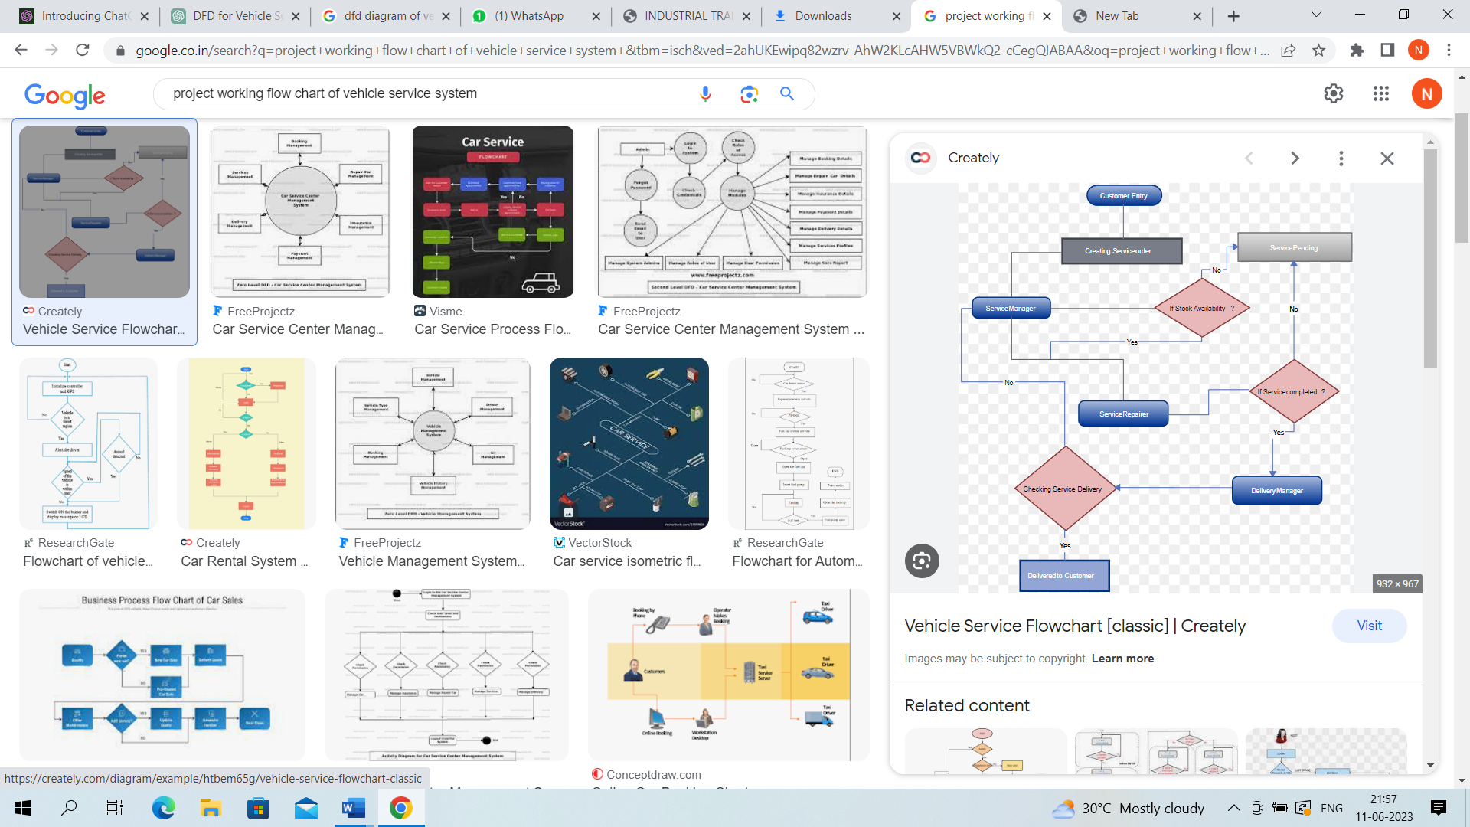

Project Working

The working of a vehicle service system developed using Django involves several components and processes. Here is an overview of the typical working of a Django-based vehicle service system:

User Registration and Authentication:
Users can register for an account by providing their details.
Django's built-in authentication system handles user registration, login, and logout processes.
User authentication ensures that only authorized users can access the system.

Vehicle Registration:
Users can register their vehicles in the system.
The system captures details such as make, model, year, registration number, and other relevant information about the vehicle.
The vehicle information is stored in the database using Django's models.

Service Scheduling:
Users can schedule service appointments for their vehicles.
They provide details such as the preferred date, time, and the type of service required (e.g., maintenance, repair, inspection).
The system checks for availability and schedules the appointment accordingly.

Service Execution:
On the scheduled appointment date, service personnel receive notifications about the upcoming service.
They perform the necessary tasks based on the service requirements, such as maintenance procedures, repairs, or inspections.
Service personnel may update the status and progress of the service in the system.

After completing the service, the system generates an invoice or estimate for the service, including details of the tasks performed and any associated charges.
Users are provided with the invoice, which may include itemized costs, taxes, and total payment due.
The system may integrate with a payment gateway to facilitate online payment transactions.

Service History and Records:
The system maintains a record of all service appointments and related information.
Users can access their vehicle's service history, including previous appointments, tasks performed, and invoices.
Service records are stored in the database and can be retrieved using Django's models and database queries.

Notifications and Reminders:
The system can send notifications and reminders to users regarding upcoming service appointments, service updates, or recommended maintenance intervals.
Notifications can be sent via email, SMS, or through the system's user interface.

Reporting and Analytics:
The system may provide reporting and analytics features to generate insights and track service performance.
Reports can include metrics such as service revenue, customer satisfaction ratings, service completion rates, or average service times.
Django's ORM (Object-Relational Mapping) can be used to fetch and process data from the database to generate reports.

Administrative Tools:
Django's built-in admin interface can be utilized for managing and administering the vehicle service system.
Authorized personnel can access the admin interface to perform tasks such as CRUD (Create, Read, Update, Delete) operations on models, manage user accounts, and generate reports.

The working of a vehicle service system in Django involves integrating the various components like user registration, vehicle management, service scheduling, service execution, invoicing, service history, notifications, and reporting. Django's modular and scalable nature allows for the development of a customized and efficient vehicle service system.

CHAPTER 7: WORKING SCREENSHOTS

Home page





Customer page

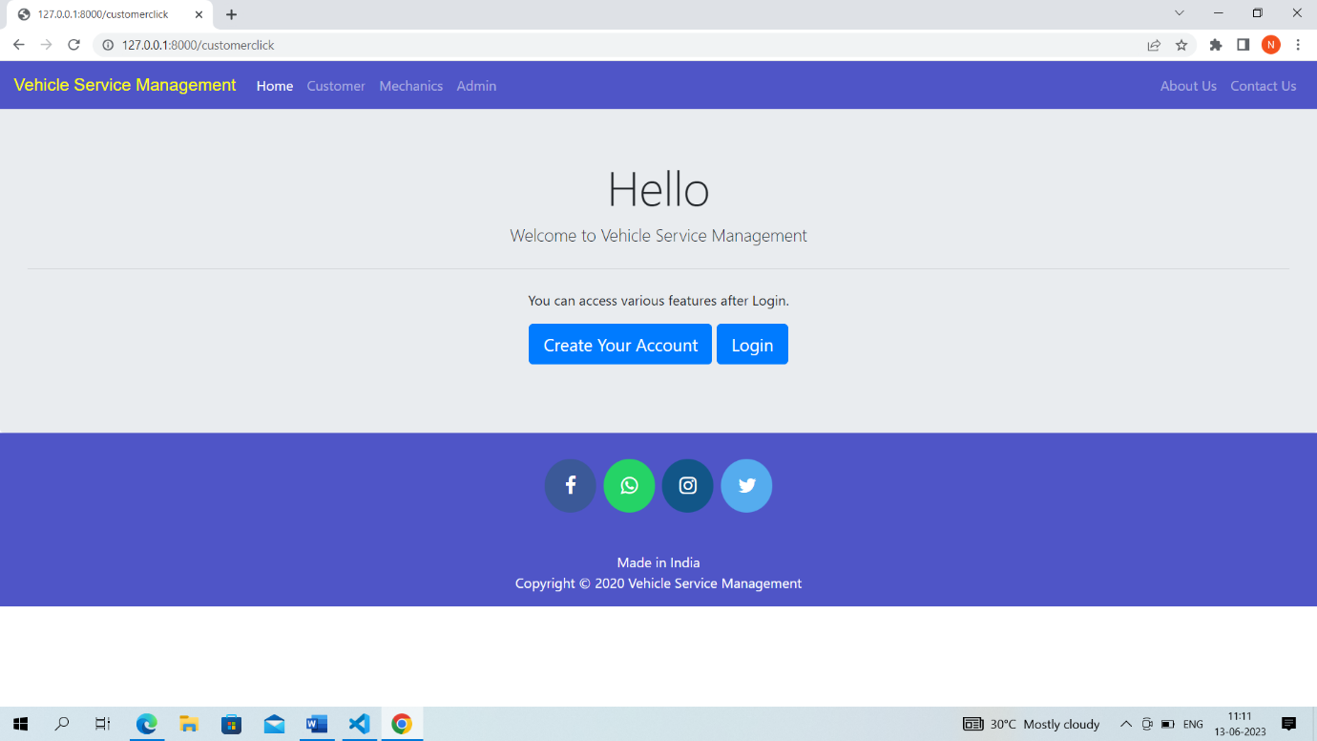

Mechanics page

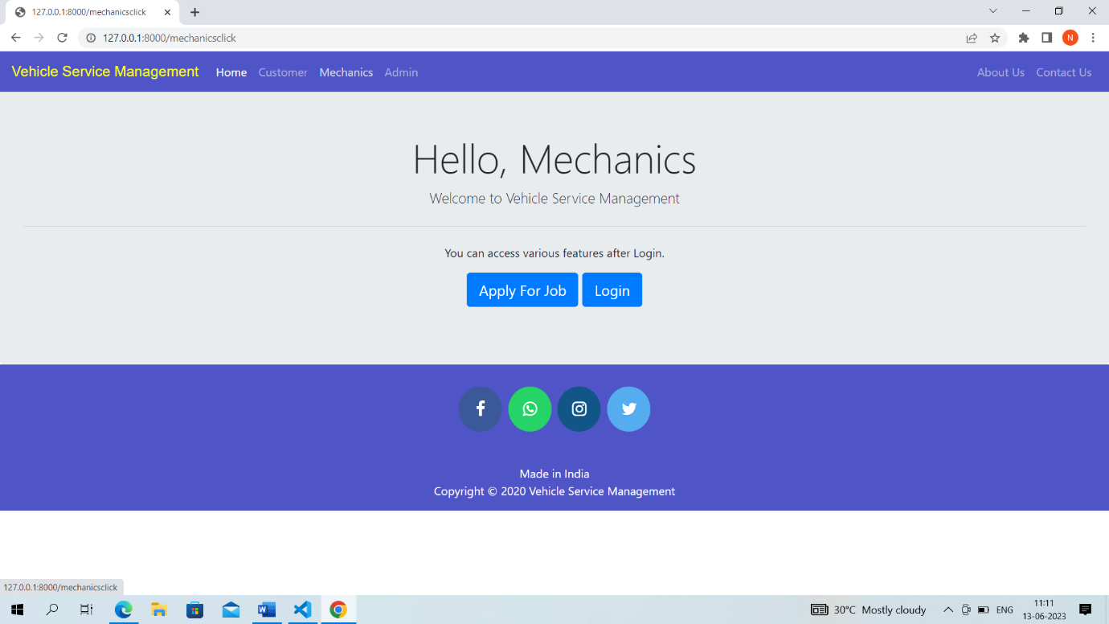

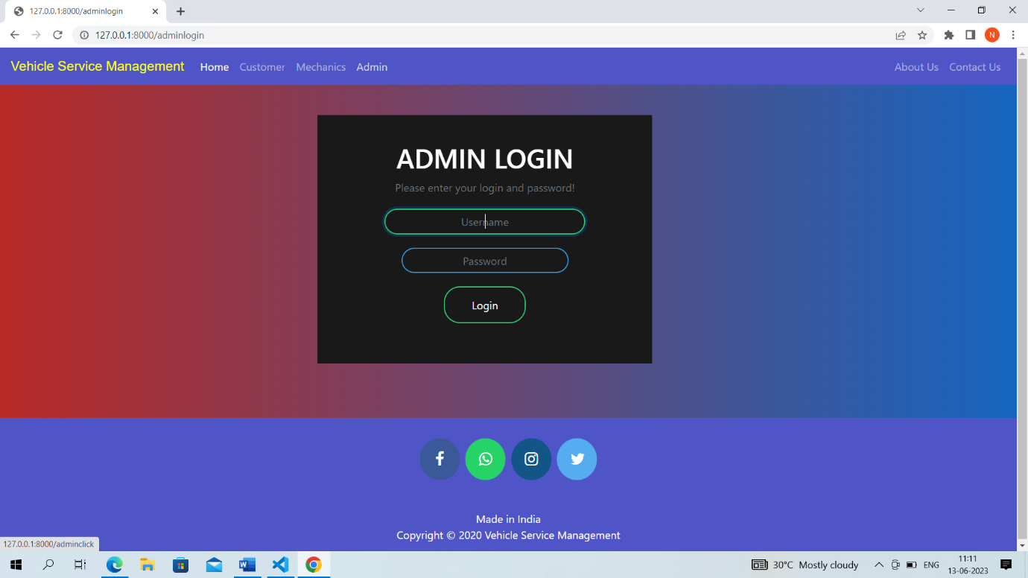

Admin page

CHAPTER 8: CONCLUSION

Conclusion
The AI Research Paper Simplifier project represents a significant step toward leveraging artificial intelligence to enhance the accessibility and understanding of academic knowledge. Research papers are an essential source of information in education and innovation, but their complexity often creates a barrier for students, beginners, and even professionals from interdisciplinary backgrounds. This project addresses that gap by providing an intelligent system capable of transforming complex research content into simplified, structured, and meaningful information.
The system is designed using advanced Natural Language Processing (NLP) techniques, which enable it to analyse large volumes of textual data and extract relevant information efficiently. By integrating pre-trained transformer-based models such as BART and T5, the system can generate concise summaries, explain technical concepts in simpler language, and highlight key insights from research papers. These capabilities significantly reduce the time and effort required to understand lengthy academic documents.
One of the major strengths of this project lies in its ability to automate the process of comprehension. Traditionally, understanding a research paper requires careful reading, domain knowledge, and significant time investment. The AI Research Paper Simplifier streamlines this process by providing quick and reliable outputs, allowing users to grasp the main ideas without going through the entire document in detail. This makes the system particularly useful for students who are new to research as well as for professionals who need to review multiple papers efficiently.
The project also emphasizes usability and accessibility through the implementation of a simple and interactive user interface using Streamlit. Users can upload research papers in PDF format and receive outputs such as summaries, simplified explanations, and key points in a matter of seconds. This ease of use ensures that the system can be adopted by a wide range of users without requiring technical expertise.
From a technical perspective, the project successfully integrates multiple components, including PDF text extraction, data preprocessing, NLP model execution, and output generation. The use of Python and its powerful libraries enable efficient handling of data and smooth implementation of machine learning models. Additionally, the modular design of the system allows for scalability and future enhancements.
However, the project also highlights certain limitations. For instance, the system may face challenges in accurately interpreting highly technical or domain-specific content, especially in fields involving complex mathematical equations, diagrams, or specialized terminology. While the current models perform well for general text simplification and summarization, further improvements can be made by fine-tuning models on domain-specific datasets or incorporating additional AI techniques.
Another important aspect of the project is its potential for future development. The system can be enhanced by adding multilingual support, enabling users to understand research papers in different languages. Advanced visualization features, such as flow diagrams and graphical summaries, can further improve comprehension. Integration with speech synthesis could allow users to listen to simplified explanations, making the system more accessible. Additionally, incorporating feedback mechanisms and continuous learning through MLOps practices can help improve the accuracy and performance of the system over time.
The broader impact of this project is significant, as it demonstrates how artificial intelligence can be used to democratize knowledge. By simplifying complex research papers, the system makes academic content more accessible to a wider audience, thereby promoting learning and innovation. It can be particularly beneficial in educational environments, where students often struggle to understand research materials.
In conclusion, the AI Research Paper Simplifier successfully achieves its goal of reducing the complexity of academic research papers and making them more understandable. It combines the power of NLP, machine learning, and user-friendly design to create an effective and practical solution. While there is scope for further improvement, the current system provides a strong foundation for future advancements. This project not only showcases the capabilities of modern AI technologies but also highlights their potential to transform the way we access and understand information.

Applications
With the rapid growth of scientific publications, understanding research papers has become increasingly challenging, especially for students and professionals who may not have deep expertise in a specific domain. Research papers often contain complex terminology, dense explanations, mathematical formulations, and domain-specific language that make them difficult to comprehend.
An AI Research Paper Simplifier addresses this problem by converting complex academic content into simplified, structured, and easy-to-understand explanations. It leverages natural language processing (NLP), machine learning, and deep learning techniques to analyse and interpret research papers.
The applications of this system extend across multiple domains, including education, research, industry, and public knowledge dissemination.

1. Application in Higher Education
One of the primary applications of an AI Research Paper Simplifier is in higher education institutions such as universities and colleges.
For Students
Students often struggle to understand research papers due to:
- Complex vocabulary
- Lack of domain knowledge
- Long and unstructured content
The simplifier helps by:
- Breaking down papers into sections like Abstract, Introduction, Methodology, and Conclusion
- Providing simplified explanations of each section
- Explaining technical terms in plain language
- Generating concise summaries
This is especially useful for:
- Final-year project work
- Assignments and presentations
- Exam preparation
For Teachers and Professors
Educators can use the tool to:
- Prepare simplified lecture notes
- Extract key concepts for teaching
- Design better course material
Impact: Enhances learning efficiency and improves conceptual clarity among students.

2. Research and Development (R&D)
In research environments, professionals are required to read and analyse a large number of research papers regularly.
The AI simplifier supports R&D by:
- Providing quick summaries of papers
- Highlighting key contributions and innovations
- Comparing different research methodologies
- Identifying research gaps
Researchers can save significant time during:
- Literature review
- Proposal writing
- Experiment design
Impact: Increases research productivity and accelerates innovation.

3. Literature Review and Thesis Writing
Literature review is one of the most time-consuming parts of academic research.
The AI Research Paper Simplifier helps by:
- Automatically summarizing multiple research papers
- Extracting key points such as objectives, methods, and results
- Organizing information in a structured format
- Providing insights for comparison between studies
This is particularly useful for:
- Thesis writing
- Dissertation preparation
- Academic publishing
Impact: Reduces manual effort and improves the quality of literature reviews.

4. Interdisciplinary Research
Modern research often involves multiple disciplines. However, understanding research outside one’s domain can be difficult.
For example:
- A computer science student reading a medical research paper
- A biology student trying to understand machine learning concepts
The simplifier:
- Translates domain-specific jargon into general language
- Explains unfamiliar concepts with context
- Provides simplified visual or logical explanations
Impact: Promotes collaboration and innovation across different fields.

5. Integration with E-Learning Platforms
The AI Research Paper Simplifier can be integrated into online learning platforms and educational tools.
Features include:
- “Simplify this paragraph”
- “Explain this concept”
- “Summarize this section”
It can also be embedded in:
- Digital libraries
- University portals
- Learning management systems
This enables students to:
- Learn at their own pace
- Interact with research content
- Gain better understanding without external help
Impact: Enhances digital learning and self-study experiences.

6. Industrial and Corporate Applications
In the corporate world, professionals often need to analyze technical research papers and whitepapers.
Applications include:
- Understanding new technologies
- Supporting product development
- Market and competitor analysis
- Innovation and strategy planning
The simplifier:
- Converts technical documents into readable insights
- Highlights important findings
- Saves time in decision-making processes
Impact: Improves efficiency and supports data-driven decisions.

7. Competitive Exam Preparation
Many competitive exams require understanding of research concepts and technical material.
Examples include:
- GATE
- UGC NET
- GRE
The AI simplifier helps students by:
- Simplifying difficult concepts
- Providing quick summaries
- Explaining research-based questions
Impact: Improves analytical thinking and exam performance.

8. Scientific Communication for General Public
Research papers are usually written for experts, making them inaccessible to the general public.
The AI Research Paper Simplifier bridges this gap by:
- Converting complex research into simple language
- Making scientific knowledge understandable
- Supporting science communication
This is useful for:
- Journalists
- Policy makers
- General readers
Impact: Promotes awareness and understanding of scientific advancements.

9. Support for Non-Native English Speakers
Many researchers and students around the world are not fluent in English, which is the primary language of research publications.
The simplifier helps by:
- Simplifying sentence structures
- Explaining difficult words
- Providing clearer interpretations
Impact: Reduces language barriers and supports global education.

10. AI-Based Question Answering System
An advanced feature of the AI Research Paper Simplifier is its ability to answer user queries based on the research paper.
Users can ask questions like:
- What is the main contribution of the paper?
- Explain the methodology used
- What are the limitations?
The system provides:
- Context-aware answers
- Accurate explanations
- Interactive learning experience
Impact: Makes research understanding more engaging and efficient.

11. Knowledge Extraction and Insight Generation
The system can extract valuable insights from research papers such as:
- Key findings
- Statistical results
- Limitations
- Future work
It presents information in:
- Bullet points
- Structured summaries
- Visual representations (if integrated with diagrams)
Impact: Enables quick comprehension and better knowledge retention.

Future Scope
As research publications continue to grow exponentially, the need for intelligent systems that can simplify and interpret complex academic content is becoming more critical. The current AI Research Paper Simplifier provides basic functionalities such as summarization, explanation, and key insight extraction. However, with advancements in artificial intelligence, natural language processing, and deep learning, the future scope of this system is vast and promising.
The system can evolve into fully autonomous research assistant capable of understanding, analysing, and interacting with scientific knowledge at a much deeper level.

1. Advanced Context-Aware Understanding
Future systems will move beyond basic summarization and develop deep contextual understanding of research papers.
Enhancements may include:
- Understanding implicit meanings and hidden insights
- Interpreting complex mathematical models
- Providing reasoning-based explanations
- Identifying assumptions and limitations automatically
Impact: More accurate and human-like interpretation of research content.

2. Multimodal Learning Integration
Future versions can integrate multimodal AI, allowing the system to process not just text but also:
- Images (graphs, charts, diagrams)
- Tables and datasets
- Equations and formulas
- Visual workflows
For example:
- Converting graphs into textual explanations
- Explaining diagrams step-by-step
- Interpreting experimental results visually
Impact: Complete understanding of research papers beyond text.

3. Personalized Learning Experience
The system can become highly personalized based on user preferences and knowledge level.
Features may include:
- Beginner, intermediate, and expert modes
- Adaptive explanations based on user background
- Customized summaries
- Learning progress tracking
Impact: Tailored learning experience for each user.

4. Real-Time Research Assistance
Future systems can act as real-time assistants for researchers and students.
Capabilities:
- Answer questions instantly while reading papers
- Suggest related research papers
- Provide citations and references automatically
- Assist in writing research papers
Impact: Increased efficiency and productivity in research work.

5. Integration with Academic Databases
The system can be integrated with major research databases and platforms.
Possible integrations:
- Google Scholar
- IEEE Xplore
- PubMed
- arXiv
Features:
- Automatic paper retrieval
- Smart recommendations
- Trend analysis in research areas
Impact: Seamless access to global research knowledge.

6. Automated Literature Review Generation
Future systems can fully automate literature reviews.
Capabilities:
- Analyse hundreds of papers simultaneously
- Identify patterns and trends
- Compare methodologies
- Generate structured review documents
Impact: Saves significant time in thesis and dissertation work.

7. Voice-Based and Conversational Interface
The system can evolve into a voice-enabled AI assistant.
Features:
- Voice commands (e.g., “Explain this paper”)
- Conversational interaction
- Audio summaries
- Interactive Q&A sessions
Impact: More natural and user-friendly interaction.

8. Cross-Language Research Simplification
Future systems will support multiple languages, making research globally accessible.
Capabilities:
- Translate research papers into regional languages
- Simplify content in native languages
- Provide multilingual explanations
Impact: Breaks language barriers in global research.

9. Integration with Augmented Reality (AR) and Virtual Reality (VR)
Advanced systems may use AR/VR technologies to visualize research concepts.
Examples:
- 3D visualization of models
- Interactive simulations of algorithms
- Virtual labs for experiments
Impact: Enhances understanding through immersive learning.

10. Plagiarism Detection and Ethical Analysis
Future versions can include:
- Plagiarism detection
- Ethical analysis of research
- Bias identification
- Validation of research authenticity
Impact: Promotes ethical and reliable research practices.

11. Smart Research Recommendation System
The system can suggest:
- Relevant research papers
- Trending topics
- Suitable journals for publication
- Collaboration opportunities
Impact: Helps researchers stay updated and connected.

12. Integration with Writing and Coding Tools
Future AI systems can assist in:
- Writing research papers
- Generating code from research methods
- Explaining algorithms with implementation
Integration with tools like:
- Code editors
- Research writing platforms
Impact: End-to-end support from understanding to implementation.

13. Domain-Specific Specialization
The system can be customized for specific fields such as:
- Medicine
- Engineering
- Law
- Finance
Each domain can have:
- Specialized terminology handling
- Context-specific explanations
- Industry-focused insights
Impact: Higher accuracy and relevance in specific fields.

14. Continuous Learning and Self-Improvement
Future systems will use:
- Reinforcement learning
- User feedback
- Real-time updates
This will allow the system to:
- Improve over time
- Adapt to new research trends
- Provide more accurate outputs
Impact: Dynamic and evolving AI system.

CHAPTER 9
9.1 REFRENCE

